PHASE 8 OF 8
Project Demonstration Phase
Auto Ticket Classification using Flow Designer

Project | Platform | Team
Auto Ticket Classification using Flow Designer | ServiceNow (Flow Designer) | SAMRIN HASRAA S  SALMA FARHANA M  SAJITHA FATHIMA S K  FATHIMA M

1. Demo Video
Item | Detail
Video link (Google Drive) | https://drive.google.com/file/d/1ToS4YSfd7P7Z9bMIzXCOWc1GtuFfXclN/view?usp=drive_link
Access setting | Anyone with the link can view (Public)
Recommended length | 6 – 8 minutes
Recording | Screen sharing with your own voice-over

How to upload
- Upload the video to Google Drive.
- Right-click → Share → General access → Anyone with the link → role Viewer.
- Copy the link and paste it above and in the README file.
- Open the link in an incognito window to confirm it plays.

5. Final Output Snapshots
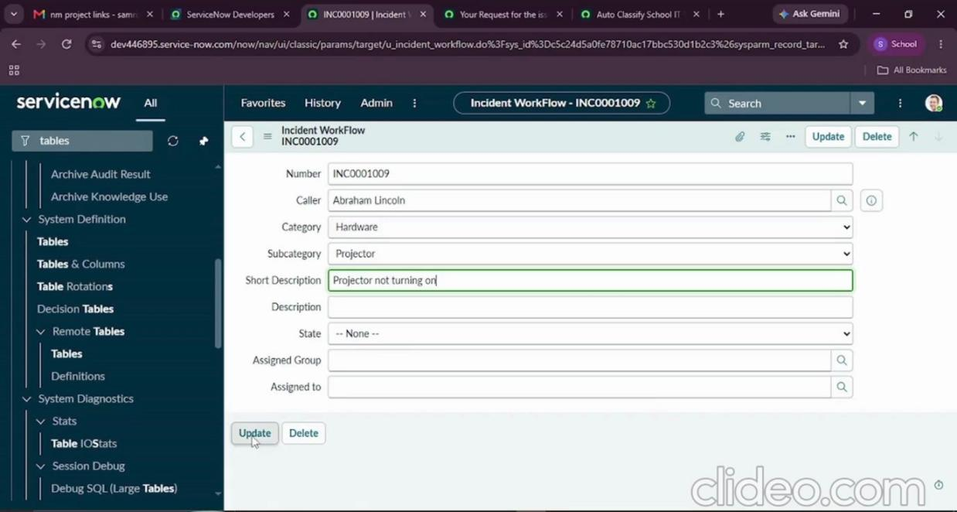
Figure 8.1 – Ticket with auto-filled Category and Subcategory
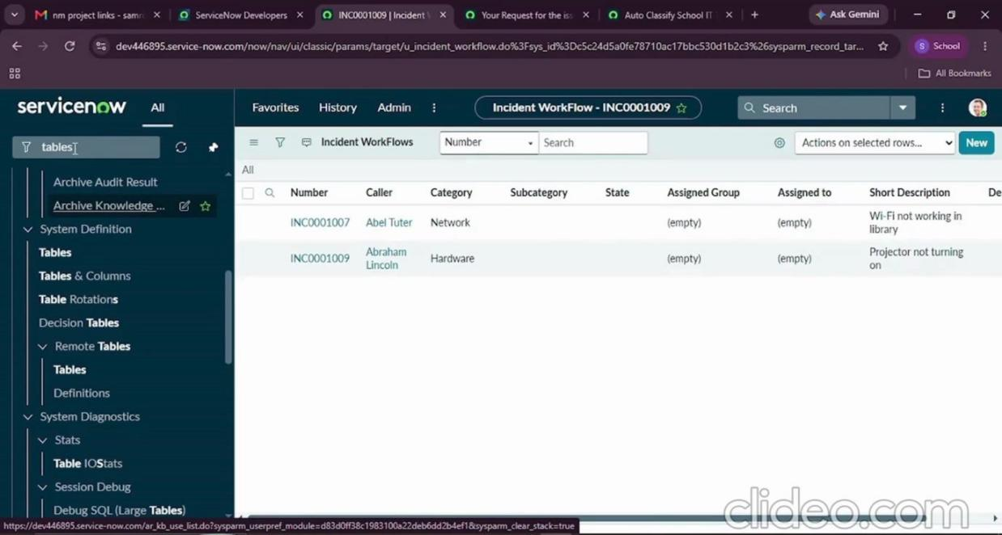
Figure 8.2 – List of classified tickets
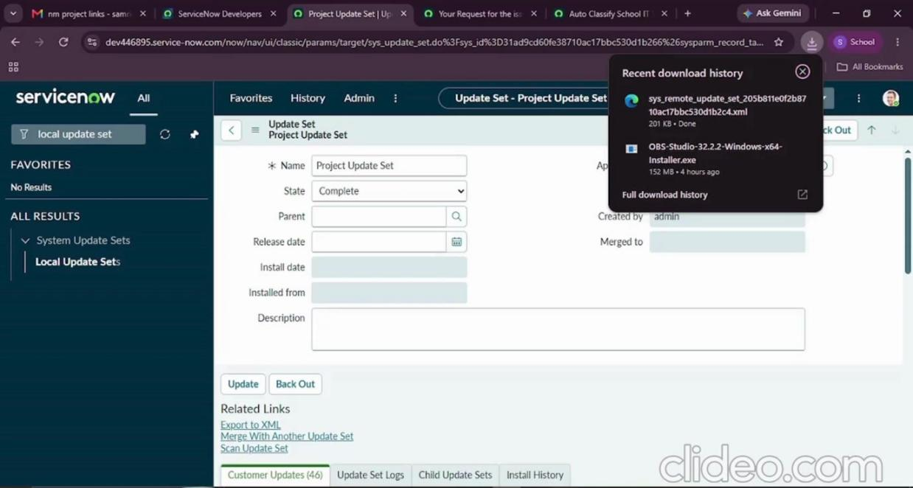
Figure 8.3 – Exported Update Set

6. Submission Summary
Submission | Link / Status
Demo video (Google Drive, public) | https://drive.google.com/file/d/1ToS4YSfd7P7Z9bMIzXCOWc1GtuFfXclN/view?usp=drive_link

